**eHearing Initiative 2019: Rationale, Design, and Implementation**

Tremblay, K.L. 1, Baylor, C.2, Davis, A.D.3, Lee, M.4, McMahon C.M5, Mosely, C.L.6, Pichora-Fuller, K.7

1. Professor (Retired), Department of Speech and Hearing Sciences. University of Washington. Seattle. USA.

2. Adjunct Associate Professor, Department of Speech and Hearing Sciences. University of Washington. Seattle, USA.

3. AD Cave Solutions Ltd, London, England.

4. Research Scientist, General Internal Medicine, Department of Medicine, University of Washington. Seattle, USA.

5. Professor Catherine McMahon, Director of Audiology and Director of the Centre for Hearing Education Application Research at Macquarie University. Sydney, Australia.

6. Clinical Supervisor and Assistant Professor, Department of Speech Pathology and Audiology, University of South Alabama, Alabama, USA.

7. Professor (Emeritus), Department of Psychology at the University of Toronto at Mississauga, Mississauga, Canada.

**BACKGROUND**

Age-related hearing loss (ARHL) is highly prevalent among adults worldwide. Although its onset is gradual and often dismissed as an expected consequence of aging, when left unaddressed, ARHL can contribute to social isolation, loss of employment, poor quality of life, reduced independence, and increased risks of dementia and early mortality (see Davis, McMahon et al. 2016; Livingstone et al. 2017 for reviews). Untreated hearing loss also negatively affects a country’s human capital, the mainstay of human and economic development  (Lim, Updike et al. 2018 <http://www.healthdata.org/infographic/what-human-capital-and-why-it-relevant)>; and for these reasons, acquired hearing loss, beginning in middle age, is recognized as a global public health concern (Davis et al. 2016; Tucci, O’Donoghue, 2017; Vos et al. 2017; Reavis, Tremblay and Saunders, 2017; Wilson et al. 2019; Ruberg 2019).

The primary clinical management intervention for people with ARHL is hearing aids and yet the majority of adults who could benefit from them do not use them. Thus, there is a need to determine why current hearing health care (HHC) interventions are underutilized and how to better meet the needs of the increasingly large number of older people whose health and ability to age successfully may depend on HHC. This point is timely because there is an unprecedented opportunity to modify HHC services and delivery now that mobile amplification technology, tele-health, and policy changes allowing over the counter options are emerging worldwide. However, before improvements to HHC can be made, it is first necessary to understand why consumers are not using existing HHC systems and what consumer preferences are for future HHC services. Without this information, there is a risk of designing new HHC services and products that continue to be underutilized. The eHearing Study was created to help inform this challenge.

The eHearing Study began in 2014 with focus groups in four English-speaking countries: Australia (Sydney), Canada (Toronto), England (London), and the U.S.A. (Seattle). The purpose of the focus groups was to query older adults about their self-reported barriers and facilitators, in each of their respective health care systems, so that consumer driven survey questions could be generated. Adults, 60 years of age or older, with and without hearing loss, were the population of interest because of the high and increasing prevalence of hearing loss in this age group, and because the risk that hearing loss poses to other aspects of their health and well-being. A multi-country comparison was adopted because ARHL is a growing global, public health problem (WHO 2015), and when viewed through an international lens it becomes possible to make within and between country comparisons. For example, aspects of HHC delivery that are reported to work well in one health care system might serve as a model for another. Moreover, similarities expressed among respondents, and common across all countries, might reflect more basic human needs that are independent of the health care model.

Results from these focus groups (McMahon et al.in press) highlighted some of the pressing views of consumers. Perceived barriers, facilitators, and preferences were largely consistent across countries and centered on the cost of services and devices, as well as the need for improved and affordable technology designed to improve signal-in-noise performance. Above all, concerns regarding social stigma of age-related hearing loss and the need for trustworthy HHC were most pervasive. These results suggest that while cost and access are important in increasing uptake of HHC, without addressing key barriers such as trust and stigma there may be limited change in help-seeking and uptake of newer services.

To probe deeper, participant remarks were used to construct data-driven questions that could be used to survey larger populations in each respective country. These questions were created by the scientific team (KT, KPF, AD, CMc) and vetted by a second set of focus groups held in London, Sydney, Seattle, and Toronto in 2015. The purpose of a second round of focus groups was to determine if the content and wording of each question was understandable and reflected the perspectives of participants in regard to HHC. To accomplish this goal, the same third-party marketing firm hired to conduct the first round of focus groups was hired to recruit new groups of adults with and without hearing loss fitting the same inclusion criteria as the initial focus groups. With the assistance of a facilitator, participants in each group, and in each country, were given the opportunity to review and critique the pool of survey questions. They were asked by the facilitator to identify any question that might be vague or incomprehensible and to suggest alternative wording when needed. They were also asked to identify: 1) what questions are most relevant to your experiences and opinions? 2) What topics have we not asked about that we should? 3) What topics could we leave out? 4) What changes should we make to the wording so that the questions are clear and understandable? The scientific team was onsite in each country and noted all comments and suggestions. Survey questions were then modified into a format that all investigators agreed upon.

The final set of survey questions can be seen in Supplement 1. They address topics such as: technology, psychosocial support, government and insurance options for financial assistance, accessibility to HHC, affordability of HHC, stigma, trust, and access to information. When a survey question or response option referenced a country-specific outlet, service, or charity by name, comparable culturally appropriate substitutions were used in the version administered in other countries. As an example, when referencing technology stores, the following options were provided: AUS (Apple Store/JB HiFi); CAN (Apple Store/Best Buy); ENG (Apple Store/Curry’s); USA (Apple Store/Best Buy). The scientific team added standardized questions related to hearing handicap, tinnitus, and trust, so results could be compared to existing published literature. Data collection ended in 2018 and the 950,000 plus data points were collated and organized through 2019.

In the present paper, we begin analyses of the data gathered using the final eHearing survey by reporting on data from all four countries pertaining to participant preferences for seeking help for HHC. Much has been written about the various journeys one goes through when seeking help for hearing problems (for a review see Knudsen et al. 2010). A common starting point for help-seeking begins with the individual acquiring information, whether it be from friends, medical providers, or websites. It is therefore important to position information and resources so that it will be optimally accessible to older adults. One of the questions contained in the eHearing survey is: “Where would you prefer to get information about hearing health care?” Therefore, we set out to analyze participant responses to this important question so that we can better understand where older adults prefer locate information. A secondary goal was to identify if these preferences vary depending on the responders degree of hearing loss or country of residence.

**METHODS**

**Participants:**

The survey was administered in two ways: (1) to **online panel members**, and (2) **in-person** at research test sites (London, Seattle, Sydney, Toronto) where a hearing test was conducted. A total of 10,744 participants initiated the survey. Of those, 10,282 completed the obligatory demographic survey questions. The target question of interest in this analysis was answered by a total of 9572 participants (online respondents = 6298 /9572 with 48.3% identifying as female; in-person respondents =1911/9572 (52.2% female).

Table 1. Demographic breakdown of people who responded to Q#41

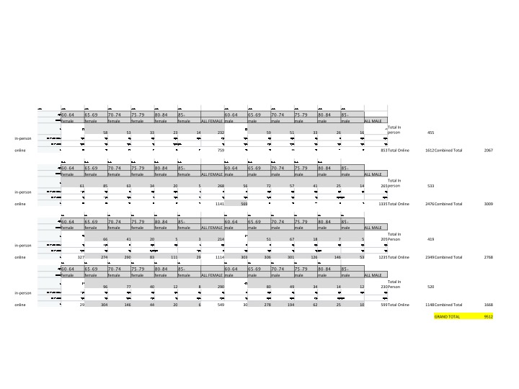

**Recruitment and Procedures**

The eHearing Study survey was conducted online and in-person in the United States (USA), Canada (Can), Australia (Aus) and the United Kingdom (UK) (2017-2018). Inclusion criteria included proficiency in the English language and being 60 years or older. Effort was made to recruit equal numbers of participants in each age band (60-64, 65-69, 70-74, and 75 or more years), gender classification, and hearing status category: 1) self-report of no hearing problems (NH), 2) self-report of hearing problems (HI), but without (-) HA and not using any other wearable technology (HI-HA), and 3) self-report of hearing problems and use of HAs or other wearable technology (HI+HA).

The survey took approximately 30-60 minutes to complete and consisted of 80, 98, or 99 questions depending on how participants self-reported their hearing ability on question 46. Questions 1-45 contained general demographic information regarding each participant (e.g., ethnicity, marital status, annual income, etc.), while question 46 asked, “Which of the following statements best describes how you feel about your hearing ability?”. The available options were: 1). I do not know if I have a hearing problem, 2). I do not have any problems with my hearing and nobody has complained about my hearing, 3). I do not have any problems with my hearing but sometimes other people tell me I have a hearing problem, 4). I do have a hearing problem but I haven’t sought any kind of help for it, 5). I do have a hearing problem and I wear hearing aids or use other technology to help me hear. Based on the answer selected, a participant would complete one of the three different versions of the survey. Participants who reported not to have hearing problems or not knowing if they had a hearing problem, completed a survey with 80 questions. Participants who self-reported having a hearing problem (HI) but not using wearable technology (e.g., hearing aids) (HI-HA) completed a 98-question version of the survey. Finally, participants who self-reported having hearing problems and using wearable technology (HI+HA) answered a 99-question survey. Participants in groups with self-reported hearing problems answered additional questions related to their help seeking experiences (e.g., hearing aid purchasing experience or reasons for not seeking help).

**Online Panel Members**

Participants were recruited by Research Now SSI, an online marketing research firm that is now Dynata <https://www.dynata.com/>. The firm was commissioned to recruit approximately adults age 60+ residing in each of the four countries. The Research Now panel is a proprietary opt-in survey panel, comprised of several million residents in the U.S., Canada, Australia and the U.K. who have agreed to participate in Research Now’s web-based surveys.

Each respondent was invited to participate in the survey in an HTML-based email invitation that included a button with a link that the respondent clicked on to take the survey. In every survey invitation, the button linked to a unique URL that provided the respondent secure access to review the consent form and complete the Web-based survey. The unique URL also supported survey resumption during the entire period (i.e., prior to completing the survey, respondents could close their browser and return to the same point in the survey and resume by simply selecting their unique URL again). Once a respondent had completed their survey and submitted the responses, that unique URL to the survey was not available for a respondent to regain access to it. This set-up prevented respondents from taking the survey more than once. Panelists were compensated for their time.

**In-Person Participants**

Using the same recruitment criteria described earlier, Schlesinger Associates was contracted to recruit approximately 500 adults 60 years of age and older, residing in the metropolitan areas of Toronto, Sydney and London. In Seattle, participants were recruited via radio advertisements, word of mouth, and through the University of Washington Communication Studies Participant Pool. Participants were compensated for their time.

**In-person** testing was held in quiet classroom and conference room settings in four cities: London, Sydney, Seattle, and Toronto. Participants were given an anonymous identification number to enter on the survey. After explaining the purpose of the study and having participants sign consent forms, research assistants demonstrated how to access the survey, which appeared on Microsoft Surface Tablets. Even though participants were instructed on how use the tablet, and how to access and complete the survey, those who exhibited continued difficulty utilizing the tablets were given the option to complete the survey on a computer (when available). Research assistants were also available to assist and answer questions as needed.

The focus of this explorative study is on the responses given to question 41 of the survey, which was available to all participants to either complete or leave unanswered. Question 41 asked, “Where would you prefer to get information about hearing healthcare? Check all that apply.” There were fourteen different options that the participant could select, and there was no restriction on how many options they could select (e.g., one participant could select one option and another participant could select all fourteen options).

Once the survey was completed, hearing thresholds were measured for each participant using the Home Hearing Test ™ (HHT) (<https://www.etymotic.com/consumer/home-hearing-test/home-hearing-test.html>). Our research (Mosley et al. 2018), and the research of others (Margolis et al., 2016; 2018), have shown that the HHT is a reliable method for obtaining hearing thresholds, that is comparable to gold standard clinical audiometry (Mosley et al. 2018). The pure-tone average (PTA) of four frequencies (0.5, 1, 2, 4 kHz) in the better ear was used to determine a participant’s degree of hearing loss (Table 2). Four categories of hearing loss were established (Clark, 1981): normal hearing (PTA below 25 dB HL), mild hearing loss (PTA 25 to 40 dB HL), moderate hearing loss (PTA from 40 to 55 dB HL), and severe hearing loss (PTA from 55 dB HL and above). The loudest output the HHT produced was an 85-dB HL pure-tone signal.

<<Table 2: Hearing category>>

|  |  |
| --- | --- |
| Better Ear  PTA (dB HL) | Hearing loss category |
| <25 db | 1 (Normal hearing) |
| 25-39 | 2 (Mild HL) |
| 40-55 | 3 (Moderate HL) |
| 55+ | 4 (Severe/profound) |

**Data Analysis:**

Because hearing thresholds could not be obtained for **online panel members**, estimations of hearing category were imputed using ordinal regression modeling (McCullagh, P, 1980). To do this, the dataset from the in-person responders was randomly split in half and ordinal regression model was bootstrapped 1000 times. Ordinal regression modeling was conducted by using the PTA hearing loss category as the outcome, with demographic covariates including gender, age, marital status and annual salary. Survey responses querying individual’s self-assessment of their hearing loss were also included in the model selection. The R package “Dredge” was used to select the best fitting model. The covariates[1] that were selected in over 75% of selections were included in a final model. We evaluated the accuracy of the model to predict hearing loss category by again splitting the global in person dataset by 0., training the final model covariates and predicting the remaining test dataset. We compared the hearing loss category predicted vs. the actual hearing loss measured via hearing testing to determine the accuracy of the model. 95% of the hearing loss categories were predicted within one degree of hearing category. Satisfied with this model selection, it was used to impute the hearing loss category for **online panel members.**

**RESULTS**

Figures 1-4 display the percentage of participants, tested **in-person**, who selected each response option. Descriptive statistics shown in Figure 1 reveal an overall preference for medical and government affiliated resources. This preference pattern appears to be similar for all countries, as shown in Figure 2. Figure 3 provides a relative spatial distribution, once again showing an overall preference for medical/government resources when compared to radio and internet advertising for in-person participants. Since a person with a mild hearing loss may have preferences that differ from someone with a moderate loss, in-person data was also analyzed according to degree of hearing loss. No apparent differences appear across the varying hearing loss categories (Figure 4) or hearing aid use (Figure 5).

Figure 1 : Total in-person responses, shown as percentages, for all four countries.

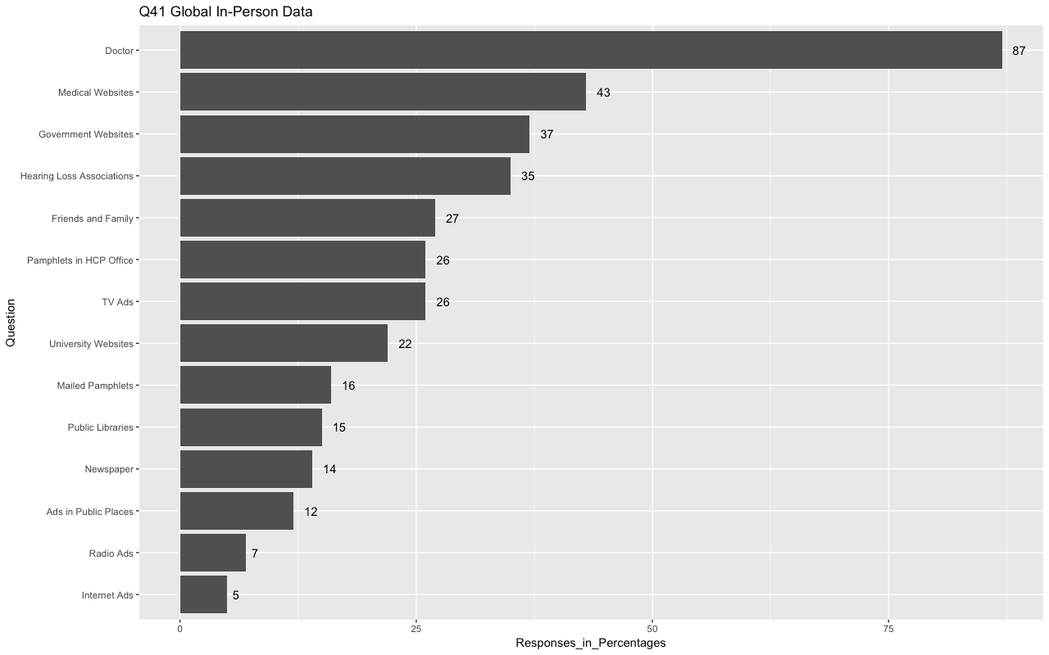

Figure 2: In-person responses, shown as percentages, for each individual country. Countries are labeled as: A). US, B). UK, C). Canada, and D). Australia.

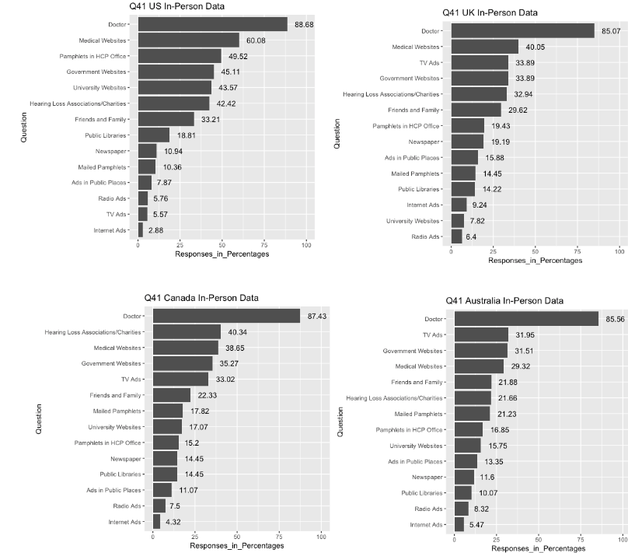

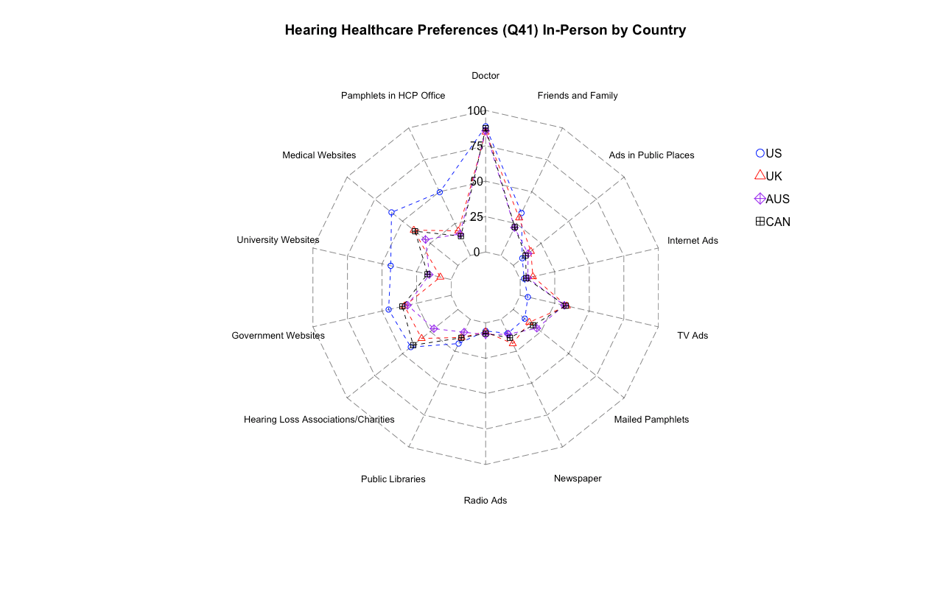

Figure 3: Radar plot illustrating percentages of options selected from **in-person** participants from each country.

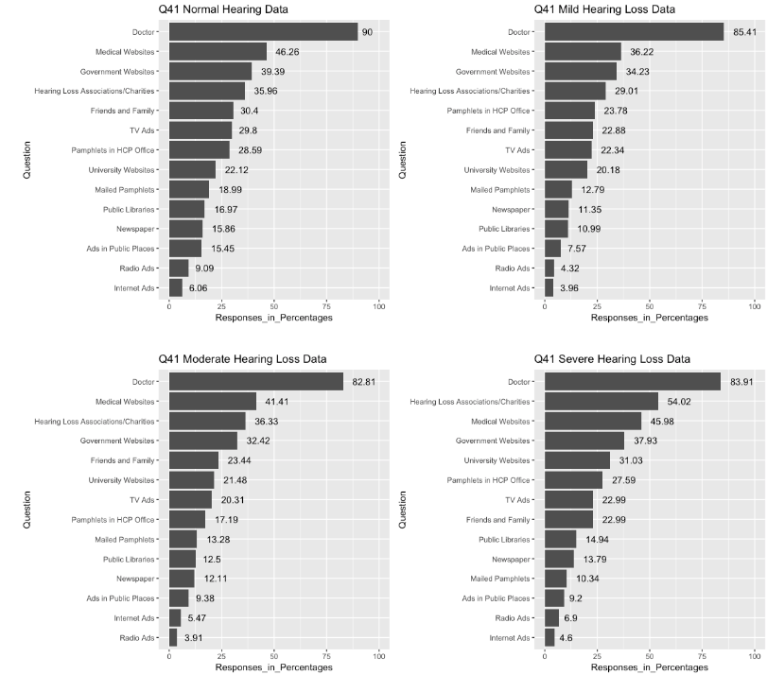

Figure 4: Percentages of options selected from in-person participants based on their category of hearing loss. The labels of hearing loss categories are labeled as: A). Normal, B). Mild Hearing Loss, C). Moderate Hearing Loss, D). Severe Hearing Loss.

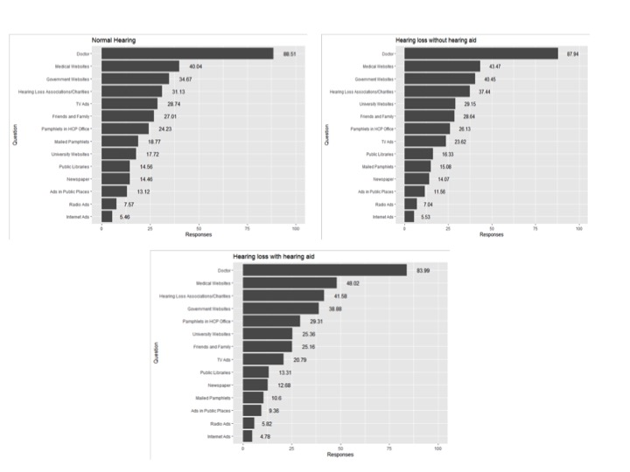

Figure 5: Percentages of options selected from in-person participants based on their hearing status A). Normal, B). Hearing Loss with a hearing aid C) Hearing Loss without a hearing aid.

Figures 6-8 display the percentages for **on-line panel members**. Figure 6 shows data from online only responders combined across all countries. Once again, online responders expressed a preference for medical/government type resources. Similar to in-person responders, there was a consistent preference to receive information about HHC from a doctor as opposed to radio advertisements etc. This preference did not appear to differ across countries (Figures 7 and 8) or by degree of hearing loss (Figure 9).

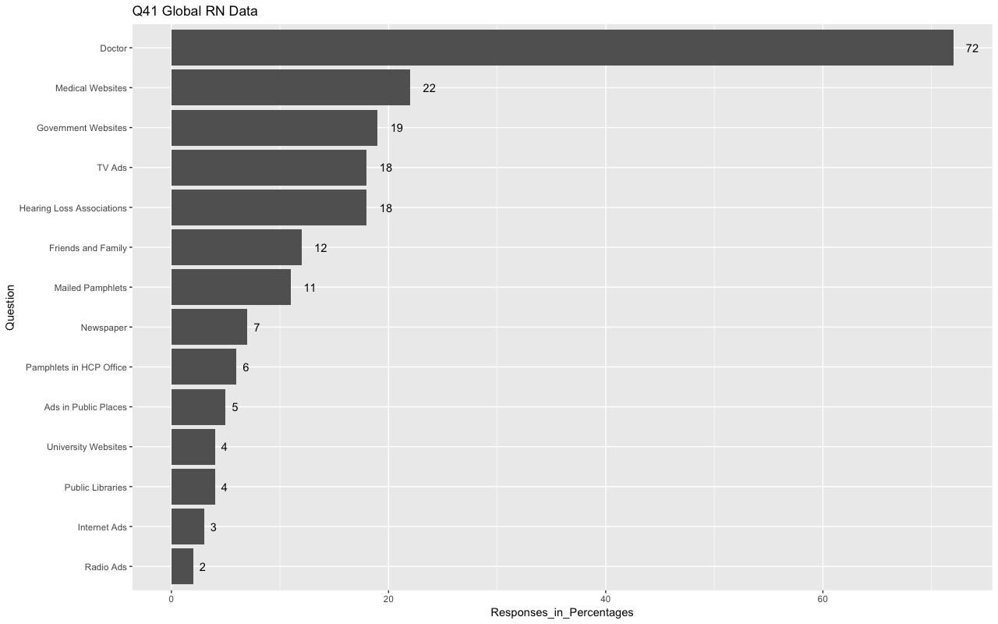

Figure 6 : Percentages of options selected from **online panel members** from all four countries combined.

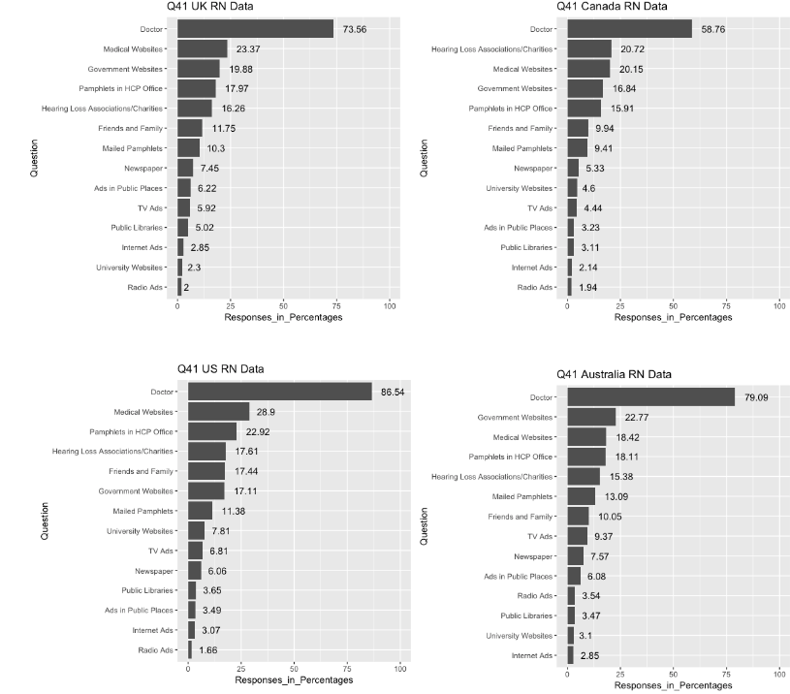

Figure 7: Percentages of options selected from **online panel members** from each country. Countries are labeled as: A). UK, B). Canada, C). US, and D). Australia.

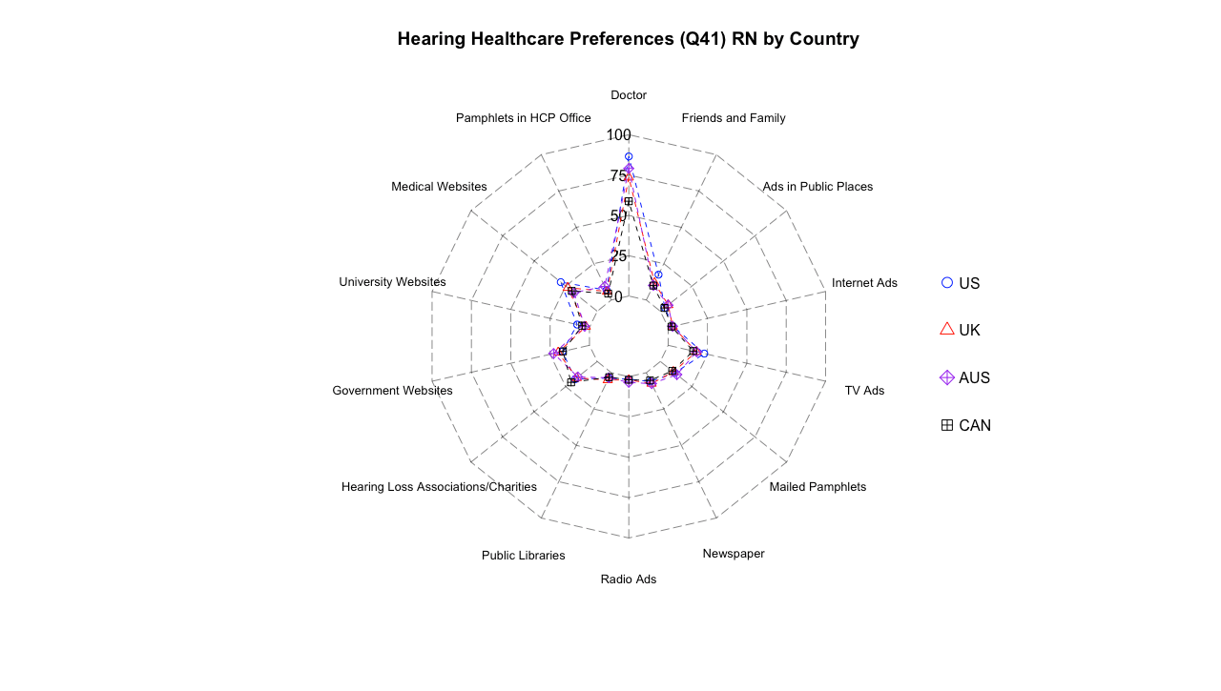

Figure 8: Radar plot illustrating percentages of options selected from **online panel members** participants from each country.

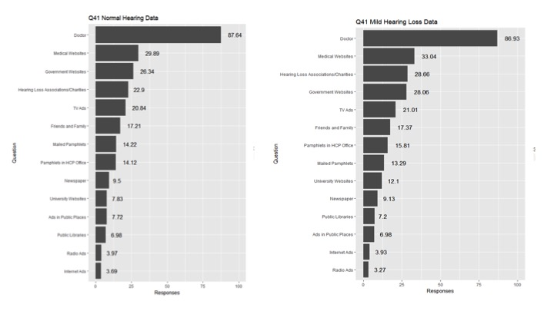

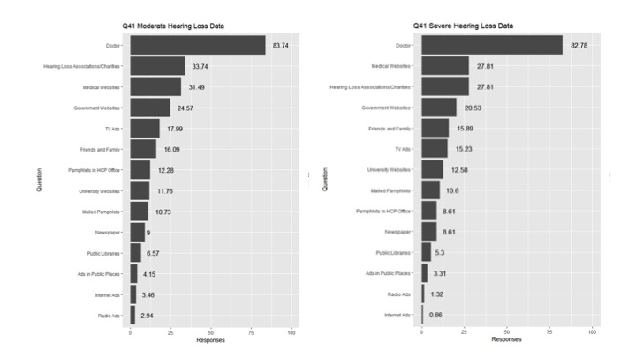

Figure 9: Percentages of options selected from **online panel members** participants based on their category of hearing loss. The labels of hearing loss categories are labeled as: A). Normal, B). Mild Hearing Loss, C). Moderate Hearing Loss, D). Severe Hearing Loss.

To determine if preferences differed by age, radar plots were constructed for **in-person** (Figure 10) and **online panel members** (Figure 11)

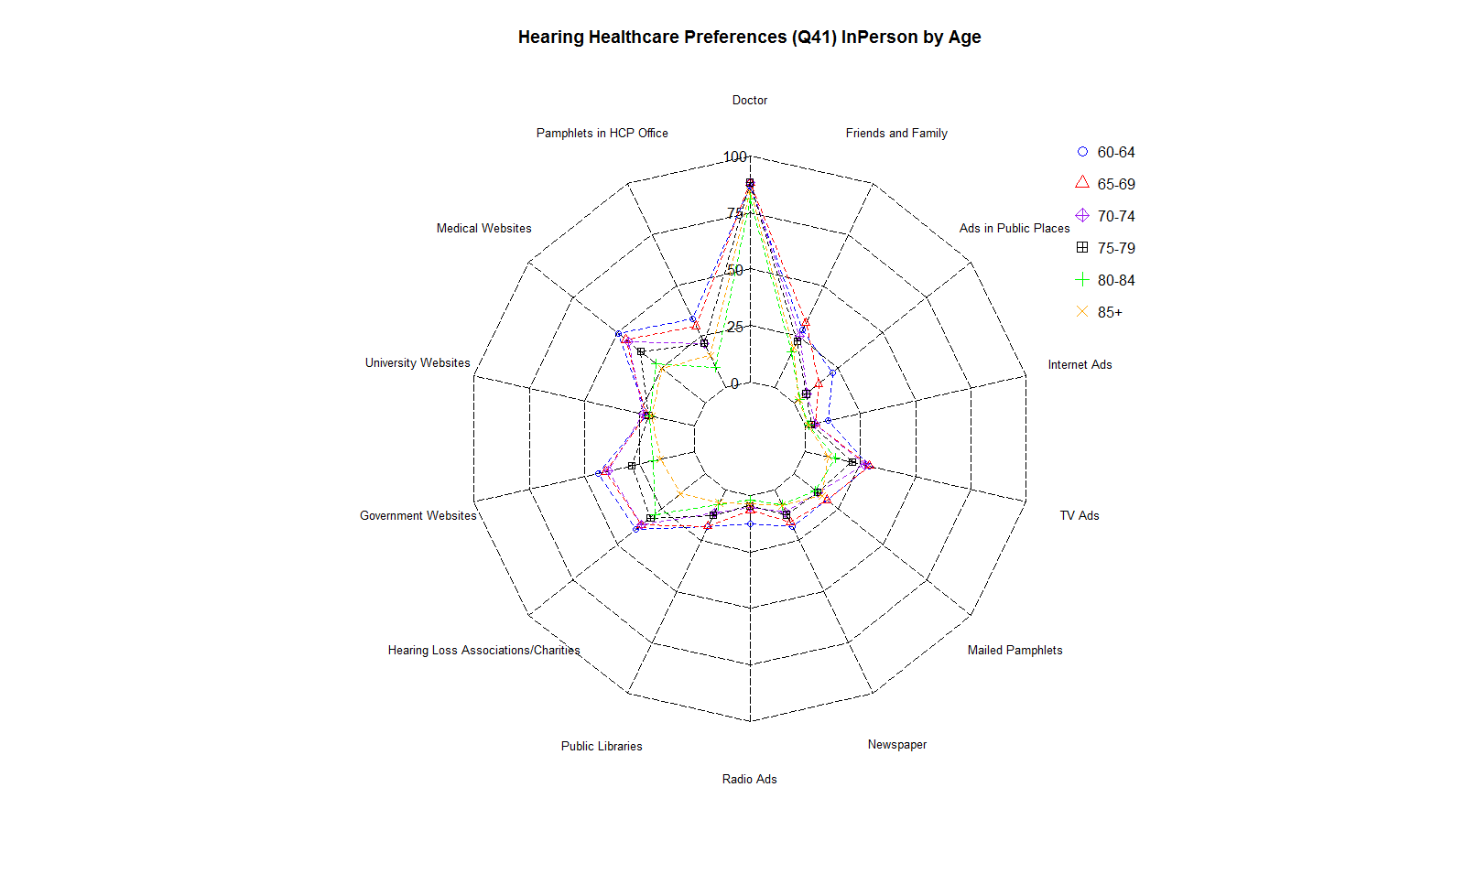

**Figure 10.**  Radar plots showing **in-person** preferencesaccording to age.

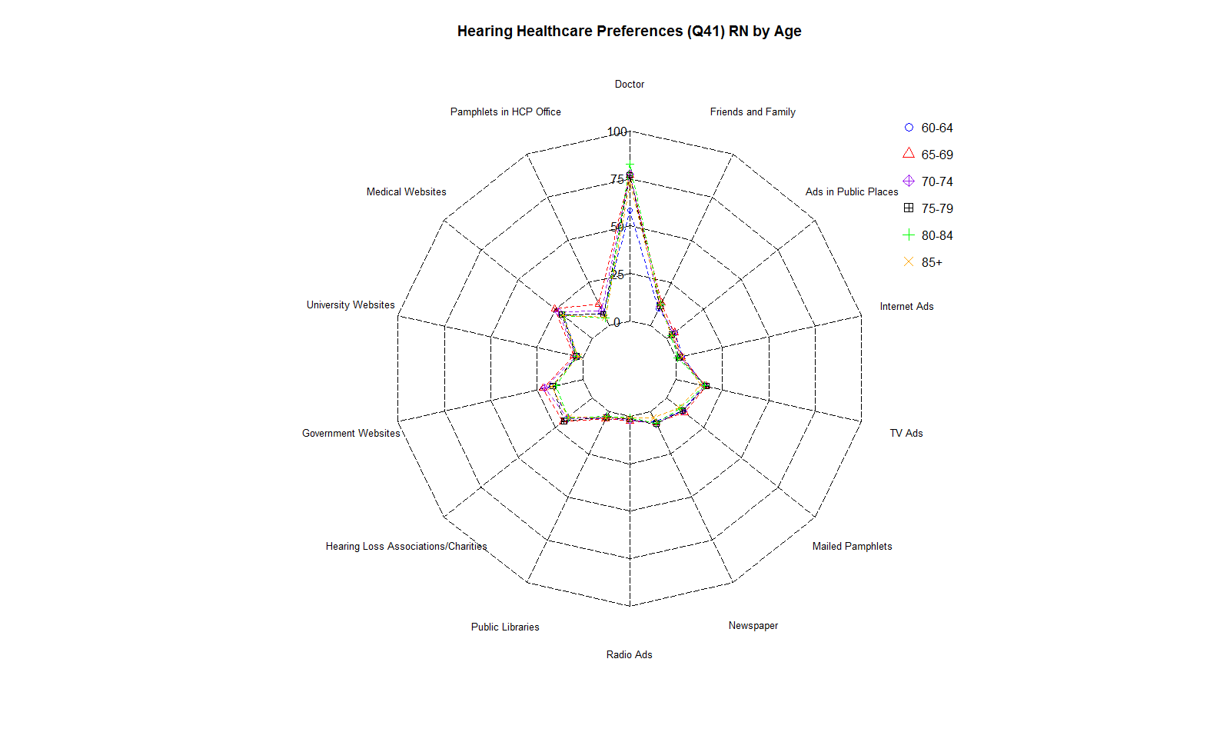

**Figure 11.**  Radar plots showing **online panel member responses** according to age.

1. Covariates were gender, household income, Are you deaf or do you have a significant hearing difficulty, Do you have a hearing problem now? and the Pathway question.